Internship title-:Tinkerer LAB Electronics internship

Name-: Nikhil chavan

Contact no.-:7249095850

Email id-: [2019nikhil.chavan@ves.ac.in](mailto:2019nikhil.chavan@ves.ac.in)

index

|  |  |
| --- | --- |
| Content | Page no. |
| 1. Introduction | 2 |
| 1. Proposed Solution | 3 |
| 1. Result (url of deployed webapp) | 4-6 |
| 1. Advantages and disadvantages | 6 |
| 1. Applicatios and Learning outcoms | 7 |
| 1. conclusion | 7 |
| 1. Reference | 8 |
| 1. Appendix | 9 |

Iot based noise pollution monitoring system

Introduction:-

Problem statement understanding :-

In infrastructure and industrial plants the rapid growth creating environmental issues like pollution (Air, Water, Noise), climate change, malfunctioning and has greatly consequence for the requirement of an, operationally adaptable, efficient, cheap and smart monitoring systems. In this context where combination of many challenges of computer science, wireless communication and electronics; the Smart Sensor Networks are an emerging field of research. In this paper a solution to monitor the noise pollution levels in industrial environment or by using wireless embedded computing system a particular area of interest is proposed.This project is based on IoT (Internet of Things), which is an emerging field in which all the devices are connected to a channel made by self (private channel). The channel is used to view the weather parameters with unique API key of channel of a particular user. To control and monitor of different activities focused by Present innovations in technology. To reach the human needs these are increasingly emerging. Most of this technology is focused on efficient monitoring and controlling different activities. To monitor and assess the conditions in case of exceeding the prescribed level of parameters (e.g., noise, CO and radiation levels) an efficient environmental monitoring system is needed. In an environment when an object equipped with sensor devices, then in this case microcontroller and various software applications becomes a self-defending Selfmonitoring and self-controlling environment and it is also called as smart environment.

Proposed solution:-

A solution for monitoring the noise and CO levels i.e., any parameter value crossing its threshold value ranges, for example CO levels in air in a particular area exceeding the normal levels etc., in the environment using wireless embedded computing system is proposed in this paper. The solution also provides an intelligent remote monitoring for a particular area of interest. In this paper i also describe a trending results of sensed or collected data with respect to the ordinary as well as specified ranges of particular parameters. The embedded system enables the user to remotely access the various parameters and store the data in cloud and This system is an integration of sensor devices with wireless communication. The quality of air is important for the survival of living beings. It is necessary to monitor air quality and keep it under control for a better future and healthy living for all. The basic mission of this project is to preserve and improve the quality of air. Compared to natural sources, man’s activities produce a much smaller amount of global pollution. Any substantial change in the nature or contents of the atmosphere has a direct consequence on how well the atmosphere performs these tasks. Atmospheric problems are made worse by weather conditions, so we should know about it correctly. we propose an air quality pollution monitoring system that allows us to monitor and check live air quality in a particular area through IoT. The sensors interact with microcontroller which processes this data and transmits it over internet. This allows authorities to monitor air pollution in different areas and take action to control the issue. Here we propose an air quality pollution monitoring system that allows us to monitor and check live air quality in particular areas through IoT. To sense presence of harmful gases/compounds in the air and constantly transmit this data to microcontroller; Air sensors are used by the system. The interaction of sensors with microcontroller processes this data as well as transmits it over internet.

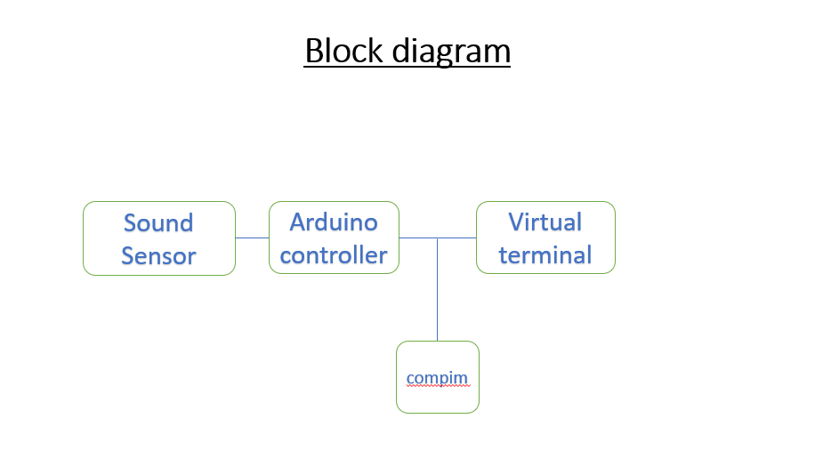

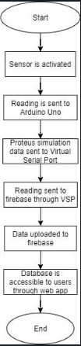Flowchart:-

Result:-

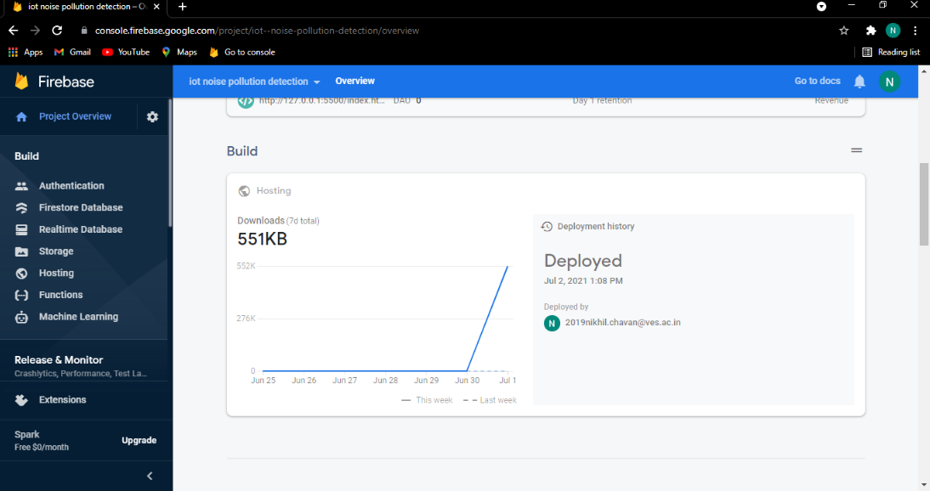

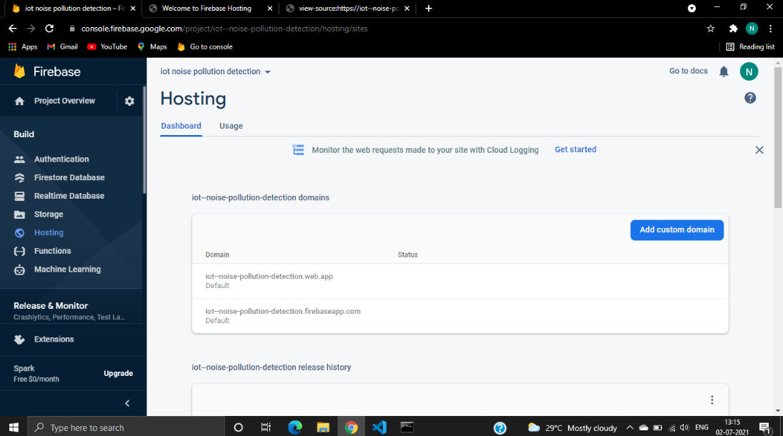

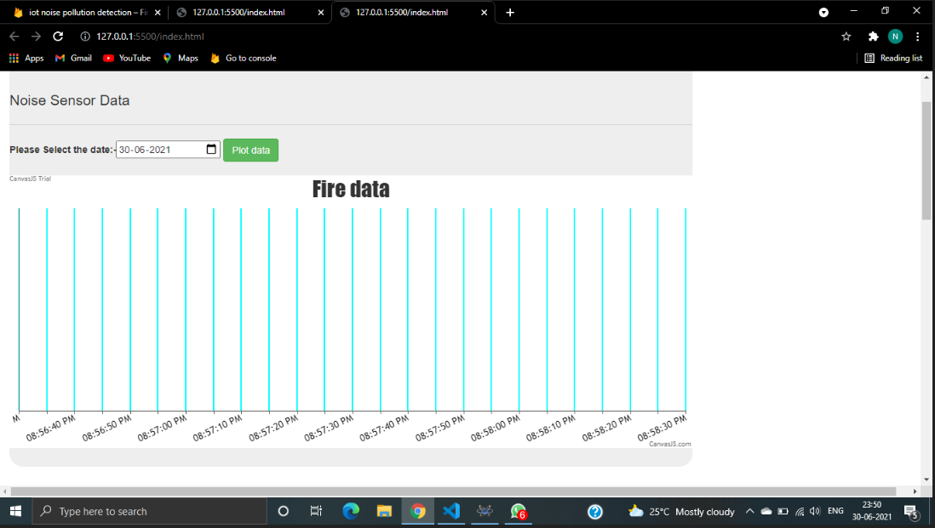

Link of the deployed webapp:-

<https://iot--noise-pollution-detection.firebaseapp.com/>

Advantages:

• Remotely we can Monitor Pollution.

• Cheap In Cost.

• Data can be used to control pollution.

• Small in size.

• Data is useful for government Health departments.

Applications:-

• Industrial pollution monitoring.

• Public places.

• School area.

• Environmental Section.

• Installed in Vehicles.

Learning outcomes:- By doing this tinkerer lab electronics internship,I have learned basic programming of Arduino controller,python programming. I understood

The basics of firebase and now I know how to send data to google firebase using python. I leran front end development of website using HTML,CSS and JAVASCRIPT. I learned to create realtime database. I also learned basic machiene lerning and I also created one simple prediction model using ML .

Conclusion:-

Thus the article explains the basic structure and system design for IOT based sound pollution monitoring system. The article also explains the basic blocks and components used in this system. It’s a complete case study for the proposed system design. The system is very much helpful for real time sound pollution monitoring. The System can be applied at remote areas and can be used to control pollution. The proposed system is cheaper in cost and smaller in size and it can be applied in industries as well as public sectors

Reference:-

[1] Pravin J, Deepak SankarA, “Industrial pollution monitoring system using LAB VIEW and GSM”, International Journal of Advanced Research in Electrical, Electronics and Instrumentation Engineering, Issue 6, June 2013

[2] Vipul Ranjan Kaushik et al., “IOT based energy meter billing and monitoring system -A case study,” International Research Journal of Advanced Engineering and Science, Volume 2, Issue 4, pp. 64-68, 2017.

[3] V. N. Patil et al., “Criminal Identification Using Arm7,” International Research Journal of Engineering and Technology, Vol: 04, Issue: 3, pp.677- 680, Mar -2017.

[4] Souvik Manna, Suman Sankar Bhunia, “Vehicular Pollution Monitoring Using lOT”, IEEE International Conference on Recent Advances and Innovations in Engineering (ICRAIE-2014), May 09-11, 2014.

[5] Yeom, I., Kim, J.M., Jung, C.W.: Dual-band slot-coupled patch antenna with broad bandwidth and high directivity for WLAN access point, Electronics Letters (2014), vol.50, no.10, pp.726,728.

[6] Huang, H.-F., Hu, Y., A Compact Dual-Band Printed Monopole Antenna for WiMax /WLAN Application.

Appendix:-

a)source code web app:-

<https://github.com/Tinkerers-Lab-VESIT-ETRX/IoT-based-noise-pollution-monitoring-system-8/tree/main>

b)Source code of Arduino:-

<https://github.com/Tinkerers-Lab-VESIT-ETRX/IoT-based-noise-pollution-monitoring-system-8/tree/main>

c) Source code of python data uploaded:-

<https://github.com/Tinkerers-Lab-VESIT-ETRX/IoT-based-noise-pollution-monitoring-system-8/tree/main>